**Amazon Cracker Sheet**

**- By Sunyul Hossen**

Note: [To Use this sheet optimally go and watch the "Cracking the Amazon coding interview🔥: The definitive prep guide" video on Debug Buzz Channel.

Link - <https://youtu.be/BEj_Oues8lE> ]

**Q) 17th August 2022**

[**https://leetcode.com/problems/candy/**](https://leetcode.com/problems/candy/)

**Q) 12th August 2022**

[**https://leetcode.com/problems/find-winner-on-a-tic-tac-toe-game/**](https://leetcode.com/problems/find-winner-on-a-tic-tac-toe-game/)

**Q) 12th August 2022**

[**https://leetcode.com/problems/design-parking-system/**](https://leetcode.com/problems/design-parking-system/)

**Q) 12th August 2022**

<https://leetcode.com/problems/lru-cache/>

**Q) 9th August 2022**

**A Z sequence is defined as:**

**Zi=P×X(Zi−1)+Q for i>0**

**Zi = 2 for i=0**

**X(K) is defined as the number of set bits in the binary form of a number K.**

**Print the number of set bits in the binary form of ZN**

**Example**

**N = 2**

**P = 1**

**Q = 3**

**Approach**

**So , Z[0] = 2 , Z[1] = P*X[2]+Q. Now X[2] = 1 as 2 can be written as 10 in binary form So, Z[1] = 1*1+3 = 4 . Similarly , Z[2] = P*X[4]+Q .Now 4 can be written as 100 . So , Z[2] = 1*1+3 = 4. Now answer is the number of set bits in Z[2] = 4, so 1.**

**EXAMPLE:**

**Sample input**

**1**

**3 5 1**

**Sample output**

**1**

**Explanation**

**Based on expression, sequence will be like 2, 8, 8,...**

**As N=1 so Z1 is 8 Number of set bits in 8(i.e 1000) is 1**

**Q) 9th August 2022**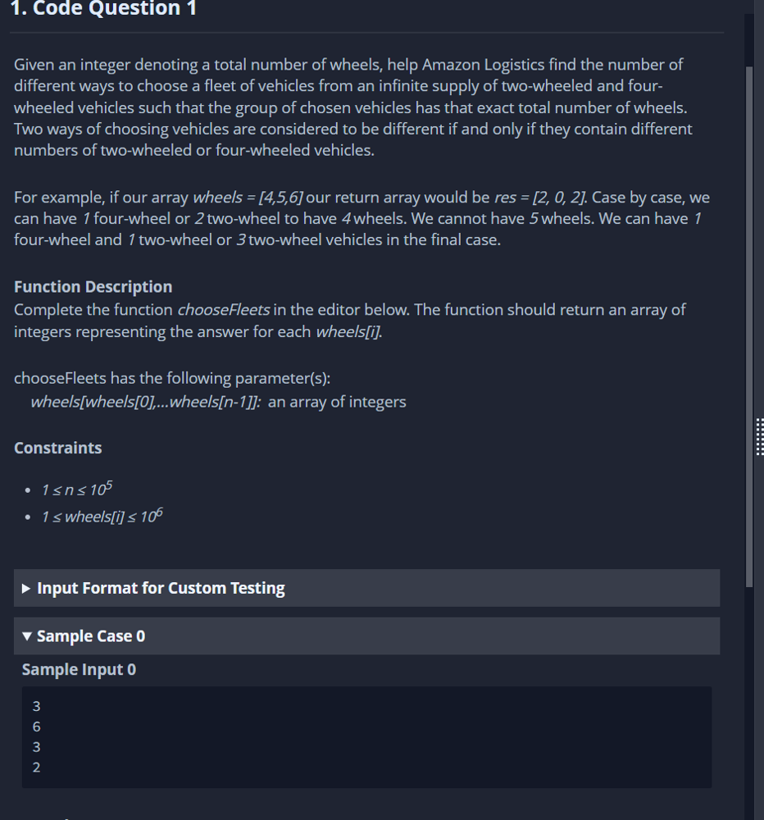

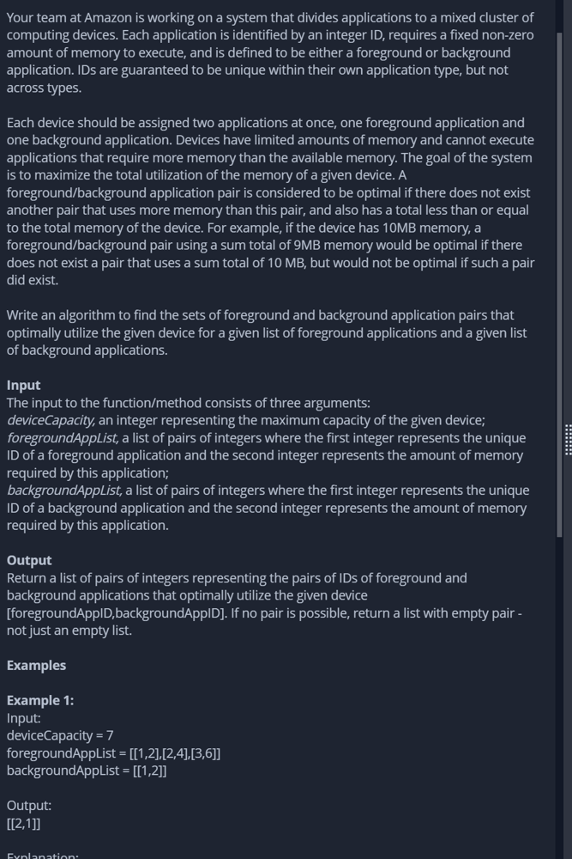

**Q) 8th August 2022**

**You are given an array A of N integers. You need to find two integers x and y such that the sum of the absolute difference between each element of the array to one of the two chosen integers is minimal.**

**Task**

**Determine the minimum value of the expression ∑i=1nmin(abs(a[i]−x),abs(a[i]−y)) if the chosen numbers are x and y.**

**Example1:**

**N = 4**

**A = [2, 3, 6, 7]**

**Approach**

**You can choose the two integers, 3 and 7.**

**The required sum = |2 - 3| + |3 - 3| + |6 - 7| + |7 - 7| = 1 + 0 + 0 + 1 = 2.**

**Example2:**

**Given**

**N = 3**

**A = [1, 3, 5]**

**Approach**

**You can choose the two integers, 1 and 4.**

**The required sum = |1 - 1| + |3 - 4| + |5 - 4| = 0 + 1 + 1 = 2.**

**The second test case**

**Example3:**

**Given**

**N = 4**

**A = [3, 2, 5, 11]**

**Approach**

**You can choose the two integers, 3 and 11.**

**The required sum = |2 - 3| + |3 - 3| + |5 - 3| + |11 - 11 |= 1 + 0 + 2 + 0 = 3.**

**Q) 8th August 2022**

**A Z sequence is defined as:**

**Zi=P×X(Zi−1)+Q for i>0**

**Zi = 2 for i=0**

**X(K) is defined as the number of set bits in the binary form of a number K.**

**Print the number of set bits in the binary form of ZN**

**Example**

**N = 2**

**P = 1**

**Q = 3**

**Approach**

**So , Z[0] = 2 , Z[1] = P*X[2]+Q. Now X[2] = 1 as 2 can be written as 10 in binary form So, Z[1] = 1*1+3 = 4 . Similarly , Z[2] = P*X[4]+Q .Now 4 can be written as 100 . So , Z[2] = 1*1+3 = 4. Now answer is the number of set bits in Z[2] = 4, so 1.**

**EXAMPLE:**

**Sample input**

**1**

**3 5 1**

**Sample output**

**1**

**Explanation**

**Based on expression, sequence will be like 2, 8, 8,...**

**As N=1 so Z1 is 8 Number of set bits in 8(i.e 1000) is 1**

**Q) 7th August 2022**

**Suppose you are given a grid of 1's and 0's. All adjacent 1's are connected components.**

**For example, in the following case you have 2 connected components because you have two "islands" of 1's.**

**1 1 0 0 1 1**

**1 0 0 0 1 1**

**1 0 0 0 0 0**

**Now you have a function called insertValue(coordinates) which takes in a row and column and inserts a 1. The function must return the updated number of connected components. So for example:**

**init:**

**1 1 0 0 1 1**

**1 0 0 0 1 1**

**1 0 0 0 0 0**

**insertValue(row=1, col=1) gives 2 connected components still because**

**grid is:**

**1 1 0 0 1 1**

**1 1 0 0 1 1**

**1 0 0 0 0 0**

**insertValue(row=1, col=2) gives 2 connected components still because**

**grid is:**

**1 1 0 0 1 1**

**1 1 1 0 1 1**

**1 0 0 0 0 0**

**insertValue(row=1, col=3) gives 3 connected components still because**

**grid is:**

**1 1 0 0 1 1**

**1 1 1 1 1 1**

**1 0 0 0 0 0**

**Q) 6th August 2022**

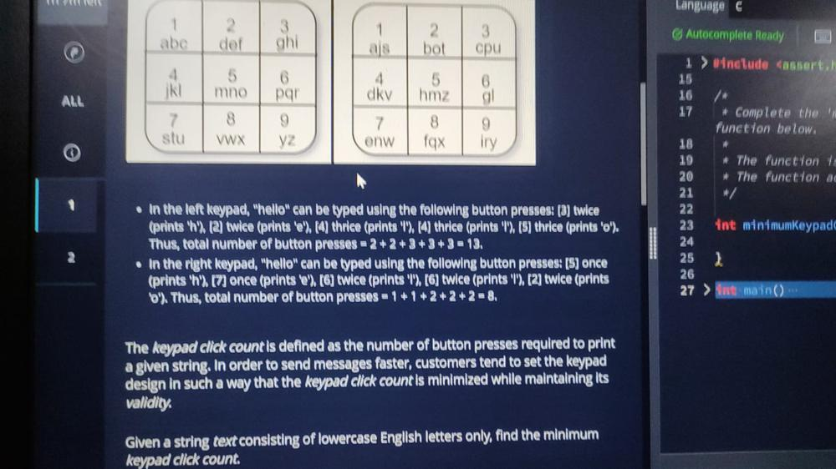

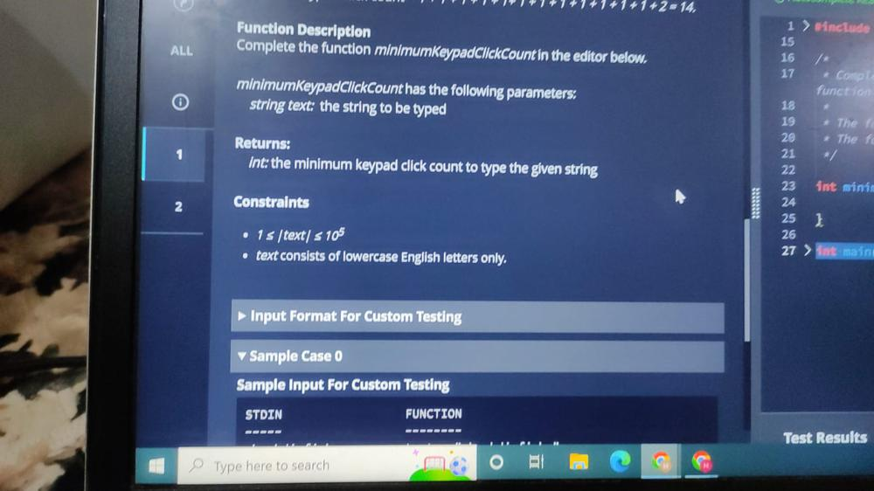

**Q) 6th August 2022**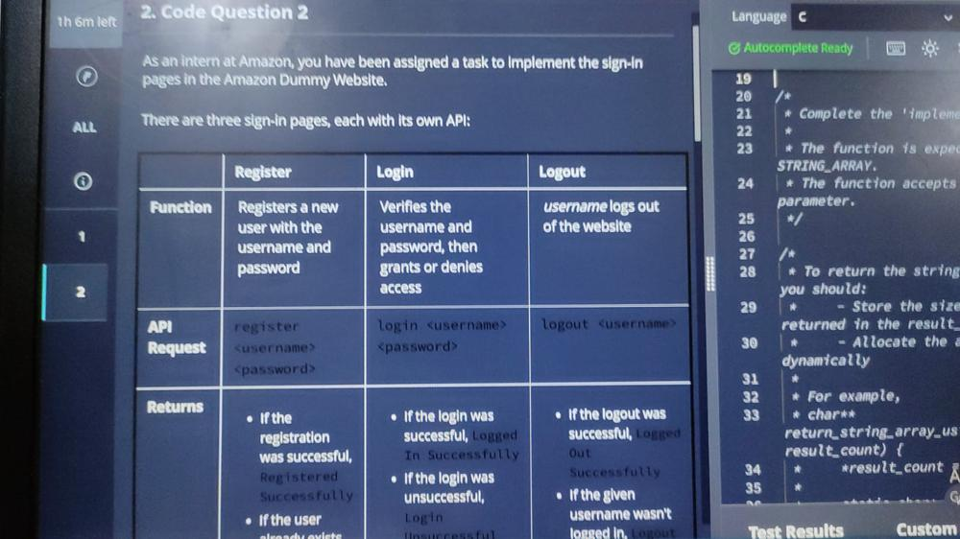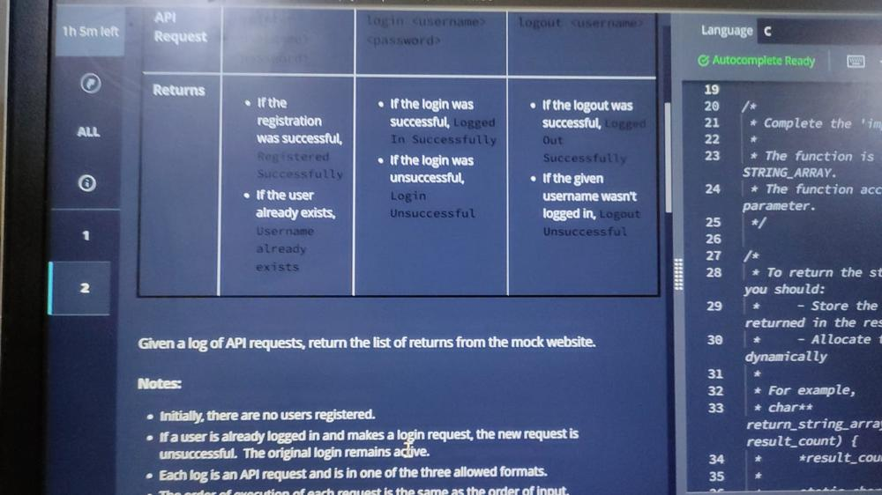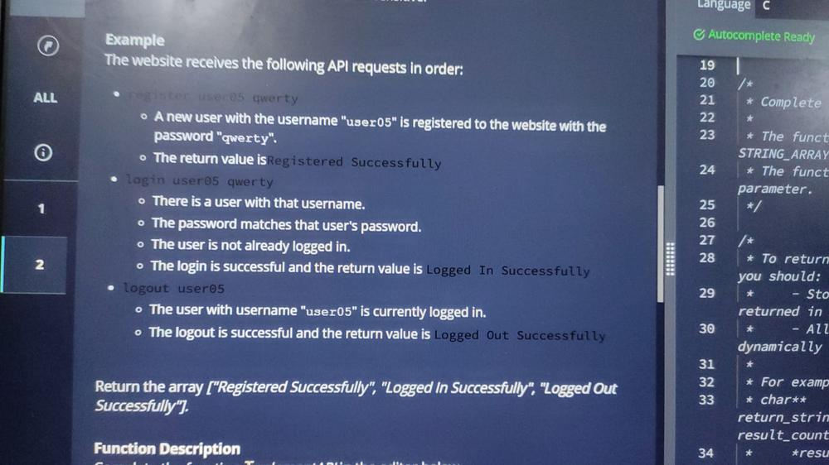

**Q) 4th August 2022**

**Given a list of cities in a 2D universe, find the number of worlds in the universe.**

**Any pair of cities in the same world have distance <= 10000 between them**

**All cities in different worlds have distance > 10000**

**eg:**

**cities -> ((0,0), (2,3), (4,2), (20000,1), (20000,3), (20002,5))**

**Ans: Number of worlds = 2**

**Q) 2nd August 2022**

1. **You are shopping on** [**Amazon.com**](http://amazon.com/) **for some bags of rice. Each listing displays the number of grains of rice that bag contains. You want to buy a perfect set of rice bags from entire search results list riceBags. A perfect is defined as:**

* **The set contains at least two bags of rice.**
* **when rice bags in set perfect are sorted in increasing ordery by grain count, it satisfies the condition;  
  perfect[i] * perfect[i] = perfect[i+1] for all 1≤ i <n. Here n is the size of the set and perfect[i] is the number of rice grains in bag i.**

**Find the largest possible set perfect and return an integer, the size of that set. If no such set is possible, then return -1. It is guaranteed that all elements in riceBags are distinct.**

**Example: Let the bags of rice available on Amazon have grain counts[3,9,4,2,16]. The following are the perfect sets.**

* **Set perfect = [3,9], the size of this set is 2.**
* **Set perfect = [4,2], the size of this set is 2.**
* **Set perfect = [4,16], the size of this set is 2.**
* **Set perfect = [4,2,16], the size of this set is 3.  
  the size of the largest set is 3.**

**Class Result{**

**/\***

**\*Complete the 'maxSetSize' function below.**

**\***

**\*The function is expected to return an INTEGER**

**\*The function accepts INTEGER_ARRAY riceBags as parameter.**

**\*/**

**public static int maxSetSize(List<Integer> riceBags){**

**// write your code here**

**}**

**}**

**Q) 1st August 2022**

**Harry and Potter took a word string. Harry chose a number M (less than the length of the**

**string) and Potter chose N (less than the length of the string). Harry will cut M alphabets**

**from the end of the string and then add it to the beginning and will give it to Potter. Then,**

**Potter will also cut N alphabets from the end of the string, add it to the beginning and ther**

**give to Harry. This process will continue till they get the original word string back.**

**For a given string and given values of M and N, find the number of turns in which they wi**

**get the original word string back.**

**Input Specification:**

**input1: Original word string**

**Value of M​**

**Q) 24th July 2022**

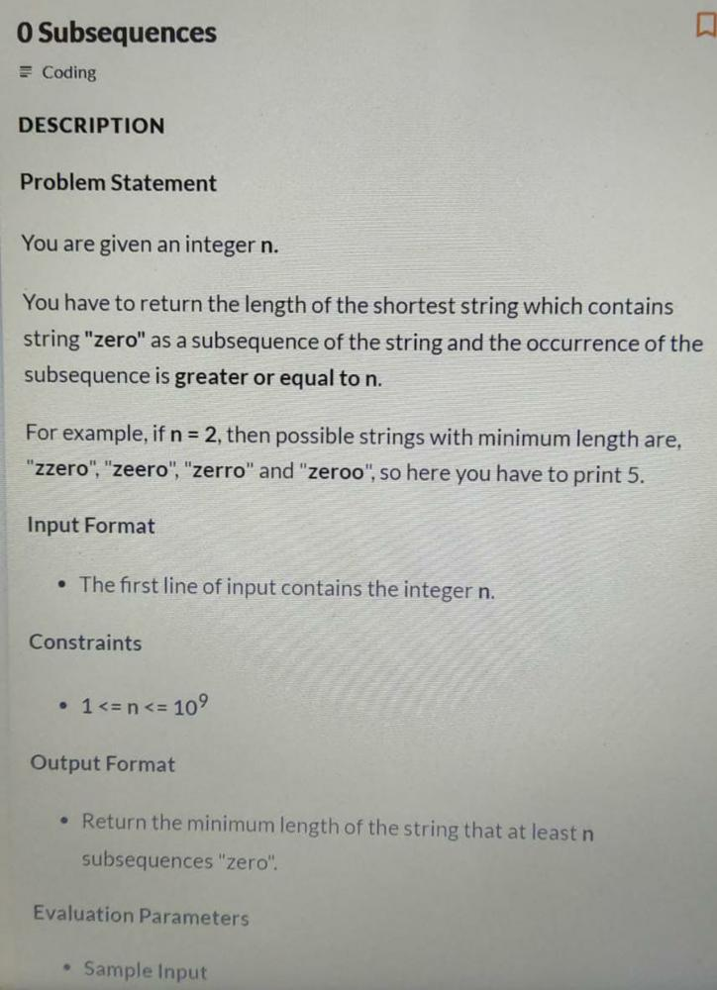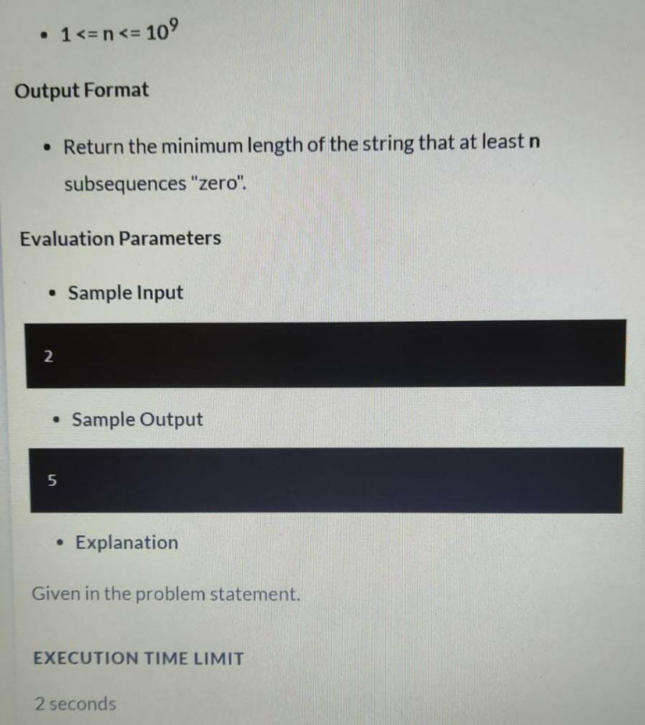

**Q) 18th July 2022**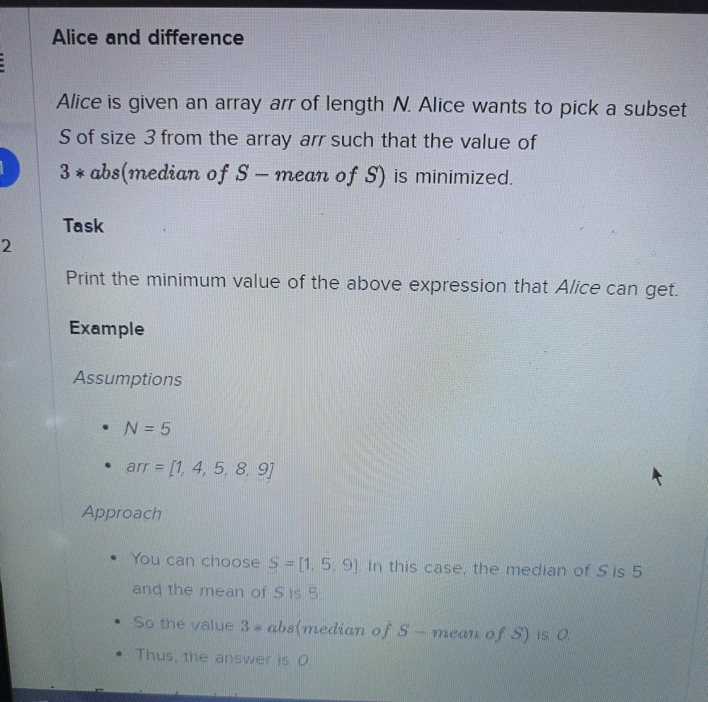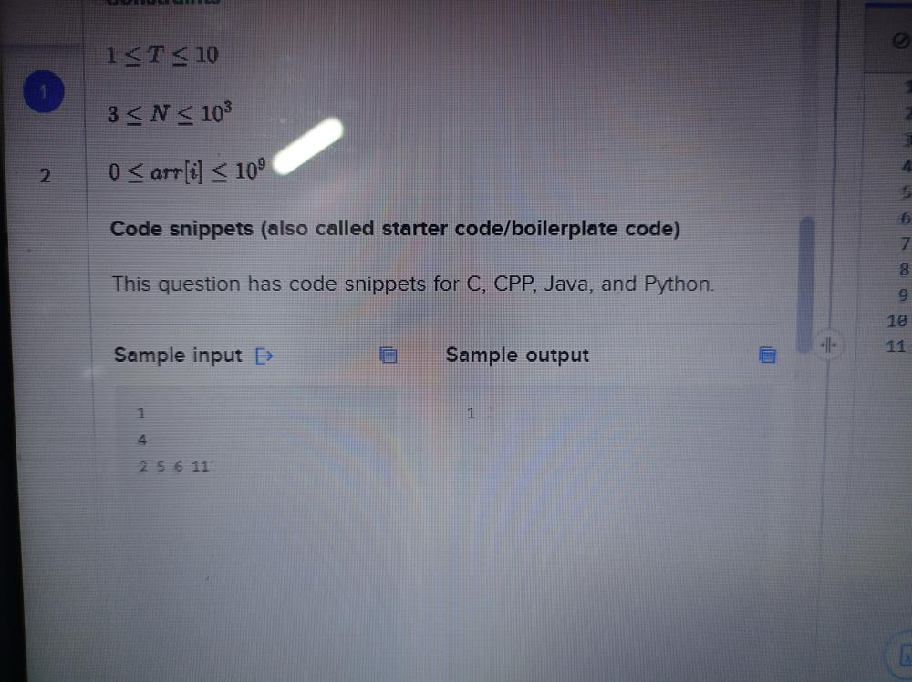

**Q) 18th July 2022**

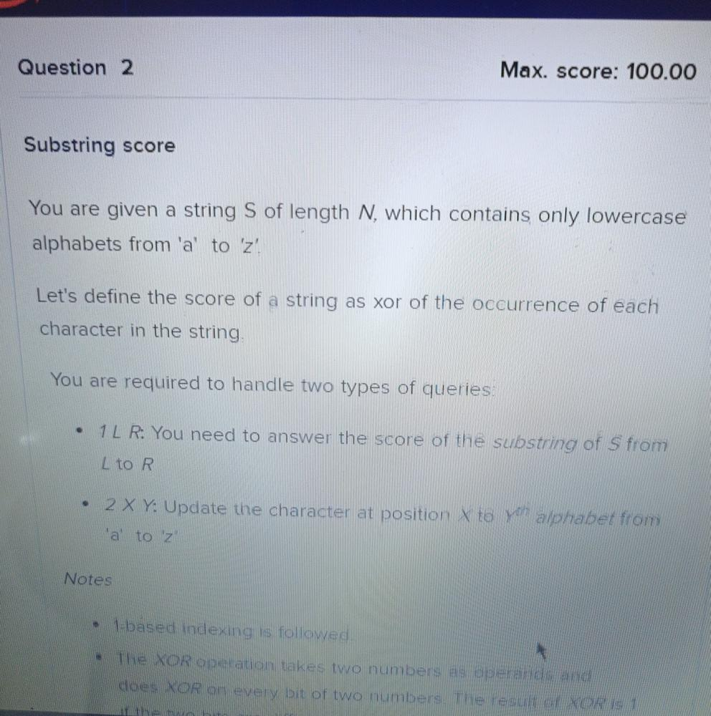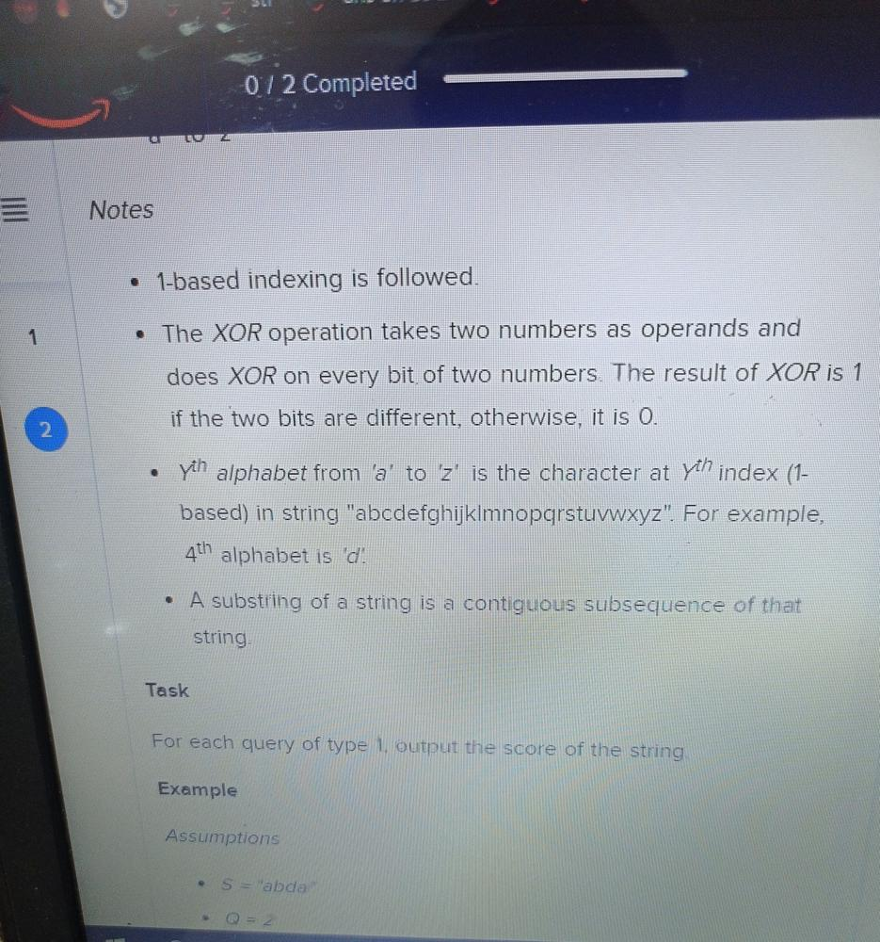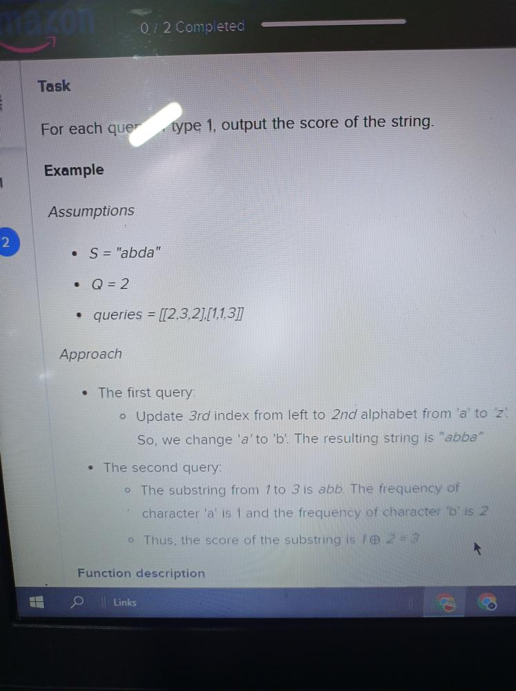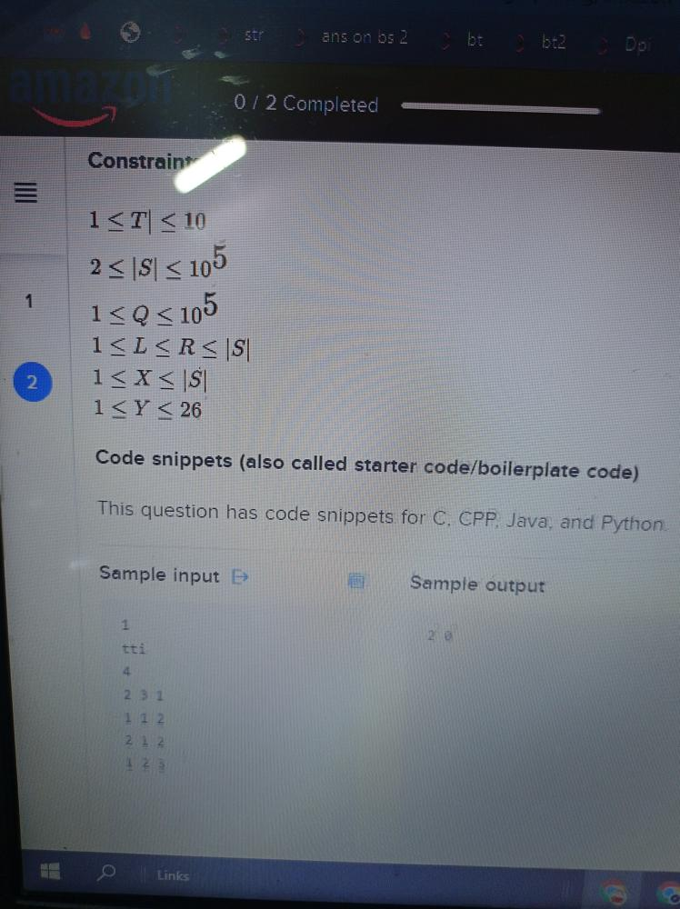

**Q) 9th July 2022**

**Minimum number of swaps to put smallest element first & largest last.**

**Q) 9th July 2022**

[**https://leetcode.com/problems/sum-of-total-strength-of-wizards/discuss/2062059/Amazon-Online-Assessment-February-2022**](https://leetcode.com/problems/sum-of-total-strength-of-wizards/discuss/2062059/Amazon-Online-Assessment-February-2022)

**Q) 2nd July 2022**

[**https://leetcode.com/problems/reorder-data-in-log-files/**](https://leetcode.com/problems/reorder-data-in-log-files/)

**Q) 2nd July 2022**

[**https://leetcode.com/discuss/interview-question/2057621/amazon-oa-usa-sde-2**](https://leetcode.com/discuss/interview-question/2057621/amazon-oa-usa-sde-2)

**Q) 1st July 2022**

[**https://archive.is/Ckx54**](https://archive.is/Ckx54)

**Q) 20th June 2022**

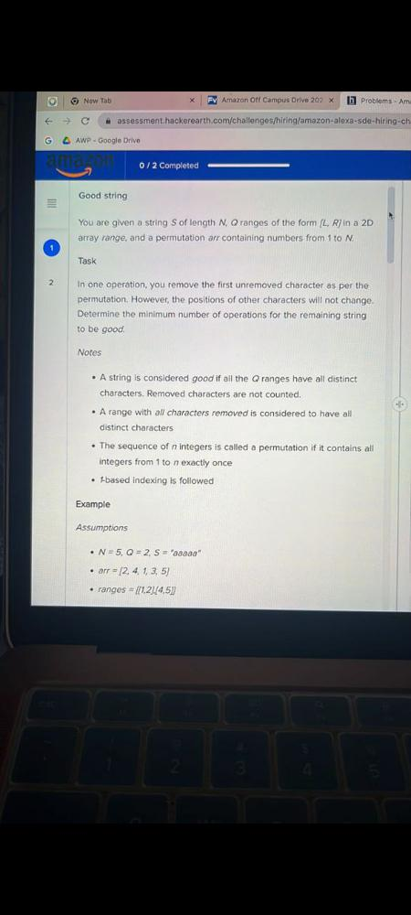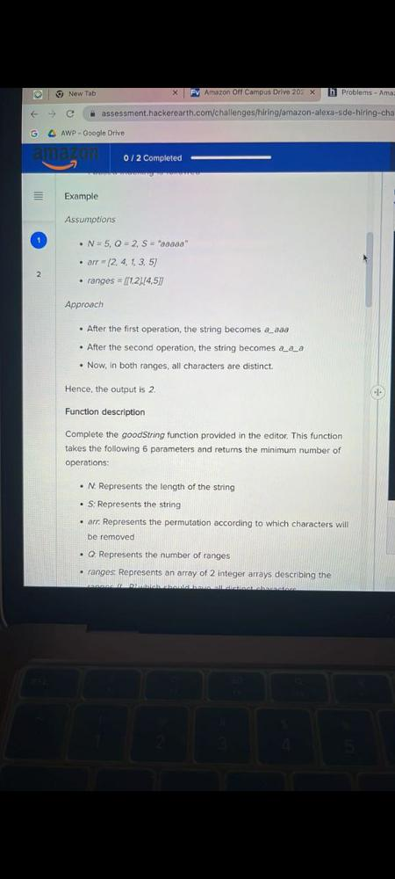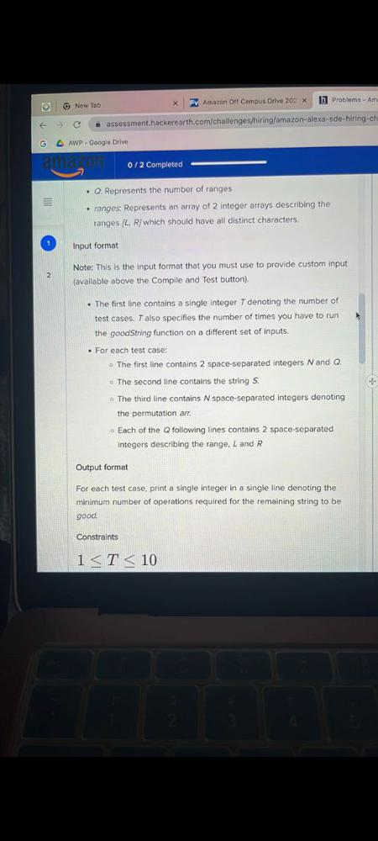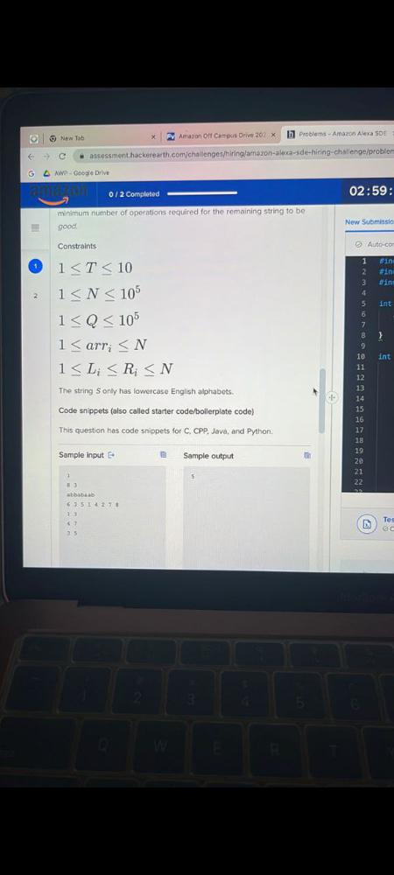

**Q) 14th June 2022**

**Minimum swaps to sort an array**

**[2, 4, 3, 1, 6] -- 3 swaps**

**[3, 2, 1] -- 3 swaps**

**[4, 7] -- 0 swap**

**[7, 4] -- 1 swap**

**Q) 14th June 2022**

**Amazon warehouse has a group of n items of various weights lined up in a row. A segment of contiguously placed items can be shipped ogether if only if the difference betweeen the weihts of the heaviest and lightest item differs by at most k to avoid load imbalance.**

**Given the weights of the n items and an integer k, fine the number of segments of items that can be shipped together.**

**Note: A segment (l,r) is a subarray starting at index l and ending at index r where l less than equal(<=) r.**

**Example:**

**weights = [1, 3, 6], k=3**

**weight difference between max and min for each (l,r) index pair are:**

**(0,0) -> max(weights[0]) - min(weights[0]) = max(1)-min(1) = 1-1 =0**

**(0,1) - > max(weights[0],weights[1]) - min(weights[0],weights[1])= max(1,3)-min(1,3)=3-1=2**

**(0,2) - > max(weights[0],weights[1],weights[2]) - min(weights[0],weights[1],weights[2])= max(1,3,6)-min(1,3,6)=6-1=5**

**(1,1) -> max(weights[1]) - min(weights[1]) = max(3)-min(3) = 3-3 =0**

**(1,2) -> max(weights[1],weights[2]) - min(weights[1],weights[2]) = max(3,6)-min(3,6) = 6-3 =3**

**(2,2) -> max(weights[2])-min(weights[2]) = max(6)-min(6) = 6-6 =0**

**as only 5 out 6 pair, is less than equal equal to k (3) , so the number of segments that can shipped together is 5.**

**Constraints**

**-- 1<=k, weights[i] <=10^9**

**-- 1 <= n <=3*10^5**

**Q) 13th June 2022**

[**https://leetcode.com/discuss/interview-question/1982251/Amazon-OA-or-USA-or-SDE2-or-Minimum-Swaps-To-Make-A-Binary-String-Palindrome**](https://leetcode.com/discuss/interview-question/1982251/Amazon-OA-or-USA-or-SDE2-or-Minimum-Swaps-To-Make-A-Binary-String-Palindrome)

[**https://leetcode.com/problems/total-appeal-of-a-string/**](https://leetcode.com/problems/total-appeal-of-a-string/)

**Q) 10th June 2022**

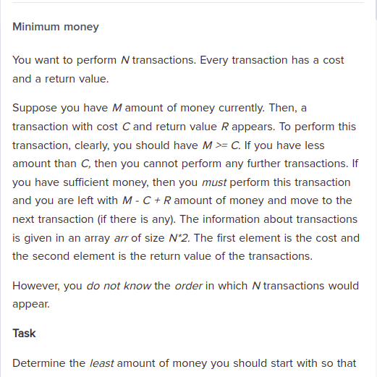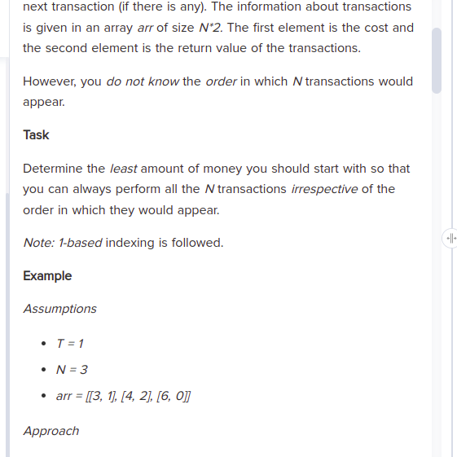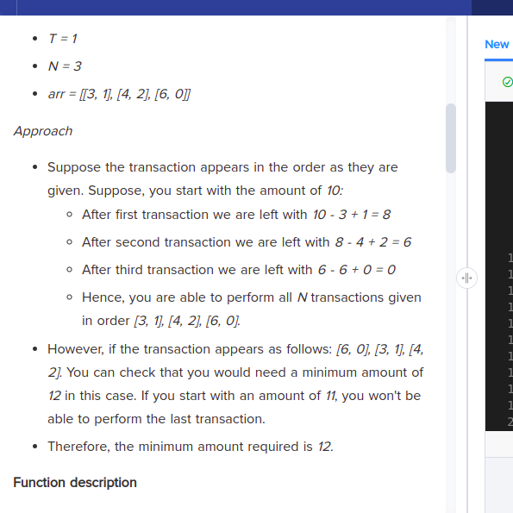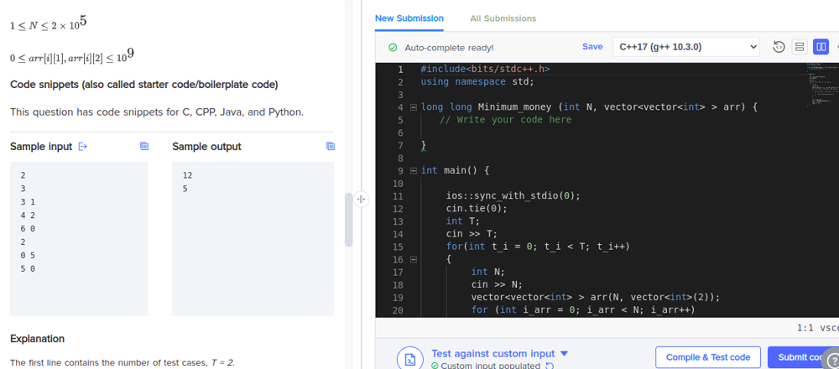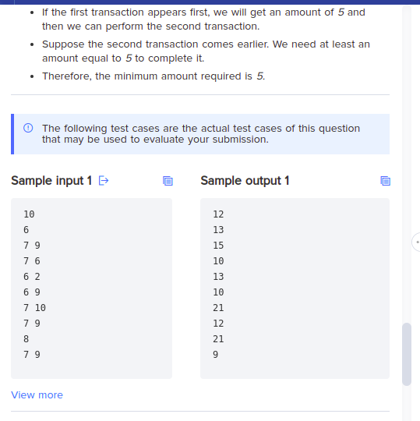

**Q) 10th June 2022**

**given an array return the count of longest continuous numbers.**

**Exp: arr={1,2,93,94,3,1001,1000}. o/p: 3**

**Q) 10th June 2022**

**Zig-zag traversal of Binary Tree**

**Q) 6th June 2022**

[**https://leetcode.com/discuss/interview-question/2034486/Prefix-Sum-Amazon-OA**](https://leetcode.com/discuss/interview-question/2034486/Prefix-Sum-Amazon-OA)

**Q) 3rd June 2022**

[**https://leetcode.com/discuss/interview-question/2068122/Amazonor-OA**](https://leetcode.com/discuss/interview-question/2068122/Amazonor-OA)

**Q) 3rd June 2022**

[**https://leetcode.com/discuss/interview-question/1988635/Amazon-or-Phone-Screen-or-Array-Strictly-Increasing-Order**](https://leetcode.com/discuss/interview-question/1988635/Amazon-or-Phone-Screen-or-Array-Strictly-Increasing-Order)

**Q) 25th May 2022**

**Find the minimum operations to be performed on the array to have maximum element in the sliding window of 3 to be greater than K. The only allowed operation would be to increase the element by 1.**

**Example :**

**Input : array = [1, 3, 0, 3, 1] , K=5**

**Output: 4**

**Explanation : Increasing the element at index (0-based Index) 1 and 3 two times.**

**Q) 25th May 2022**

**Find the minimum number that can be XOR-ed to each element in the given sorted array to arrange the array to be sorted in descending order**

**Input : [2, 2, 4, 5]**

**Output : 5**

**Explanation : If each element is XOR-ed with 5, will yield the following array : [7, 7, 3, 0]**

**Q) 24th May 2022**

**Given a binary string write an algorithm to calculate minimum number of swaps required to make it a palindrome for eg 11101 requires on swap between 3rd and 4th to make it 11011**

**Q) 24th May 2022**

**Given a password determine the strength of the password which is calculated by getting substrings in password and calculating strength based on number of unique characters in the substring and adding all the strength  
Eg**

**Good**

**g - 1**

**o - 1**

**o - 1**

**d -1**

**go - 2**

**oo - 1**

**od- 2**

**goo - 2**

**ood - 2**

**good - 3**

**total = 16**

**Q) 23rd May 2022**

**Determine the min distance required for the robot to remove the obstacle**

**Input is given as a 2D array which consists of 0, 1 and 9**

**9 is the obstacle, can pass through 1 and cannot pass through 0**

**Robot can move top, left, right and bottom**

**Input: [[1,0,0],[1,0,0],[1,9,1]]**

**output: 3**

**Q) 22nd May 2022**

[**https://leetcode.com/discuss/interview-question/1998840/Amazonor-OA-or-Minimum-Days-to-Deliver-All-Parcels**](https://leetcode.com/discuss/interview-question/1998840/Amazonor-OA-or-Minimum-Days-to-Deliver-All-Parcels)

**Q) 22nd May 2022**

[**https://leetcode.com/discuss/interview-question/1636493/Amazon-or-OA-or-Max-Length-of-Valid-Server-Cluster**](https://leetcode.com/discuss/interview-question/1636493/Amazon-or-OA-or-Max-Length-of-Valid-Server-Cluster)

**Q) 10th May 2022**

**Given an array consisting of N integer and two number k,d.**

**Task1-From the given array we can choose k consecutive elements one after in array and after that leave an array element.Then we calculate maximum sum of all such consecutive element containing subarray.**

**Task2-From the given array we can choose k+d consecutive elements one after in array and after that leave an array element.Then we calculate maximum sum of all such consecutive element containing subarray.**

**Find the difference between task1 and task 2 ans.**

**ex 1->arr=[1,2,3,4,8,9,10]**

**k=2,d=1;**

**Task1 elements {3,4}+{9,10}=7+19=26**

**Task2 elements {1,2,3}+{8,9,10}=6+27=33;**

**output=33-26=7**

**Q) 4th May 2022**

**You are given a tree with V vertices numbered from 1 to N.**

**The ith edge connects Vertex xi and Vertex yi bidirectionally. You**

**have to divide this tree into three connected components by cutting**

**any two edges of the tree. Let the three components be C1,**

**C2 and C3. Let X1, X2 and X3 be the XOR of all the vertices of the**

**components C1, C2 and C3 respectively.**

**Task**

**Minimize the difference between the maximum and minimum xor**

**values of the components. In short, you have to minimize the value**

**of max(X1, X2 ,X3)-min(X1, x2,X3)**

**Q) 3rd May 2022**

[**https://leetcode.com/problems/3sum/**](https://leetcode.com/problems/3sum/)

**Q) 3rd May 2022**

[**https://leetcode.com/problems/course-schedule/**](https://leetcode.com/problems/course-schedule/)

**Q) 27th April 2022**

[**https://leetcode.com/discuss/interview-question/1655441/amazon-oa**](https://leetcode.com/discuss/interview-question/1655441/amazon-oa)

**Q) 27th April 2022**

[**https://leetcode.com/discuss/interview-question/1904966/Amazon-orOAorset-7**](https://leetcode.com/discuss/interview-question/1904966/Amazon-orOAorset-7)

**Q) 16th April 2022**

[**https://leetcode.com/discuss/interview-question/1858858/amazon-oa**](https://leetcode.com/discuss/interview-question/1858858/amazon-oa)

**Q) 16th April 2022**

[**https://www.chegg.com/homework-help/questions-and-answers/order-ensure-maximum-security-developers-xyz-employ-multiple-encryption-methods-keep-user--q95120166**](https://www.chegg.com/homework-help/questions-and-answers/order-ensure-maximum-security-developers-xyz-employ-multiple-encryption-methods-keep-user--q95120166)

**Q) 7th April 2022**

[**https://leetcode.com/problems/remove-nth-node-from-end-of-list/**](https://leetcode.com/problems/remove-nth-node-from-end-of-list/)

**Q) 7th April 2022**

[**https://leetcode.com/problems/design-parking-system/**](https://leetcode.com/problems/design-parking-system/)

**Q) 7th April 2022**

[**https://leetcode.com/problems/missing-number/**](https://leetcode.com/problems/missing-number/)

**Q) 7th April 2022**

[**https://leetcode.com/problems/course-schedule/**](https://leetcode.com/problems/course-schedule/)

**Q) 4th April 2022**

[**https://leetcode.com/problems/nested-list-weight-sum/**](https://leetcode.com/problems/nested-list-weight-sum/)

**Q) 2nd April 2022**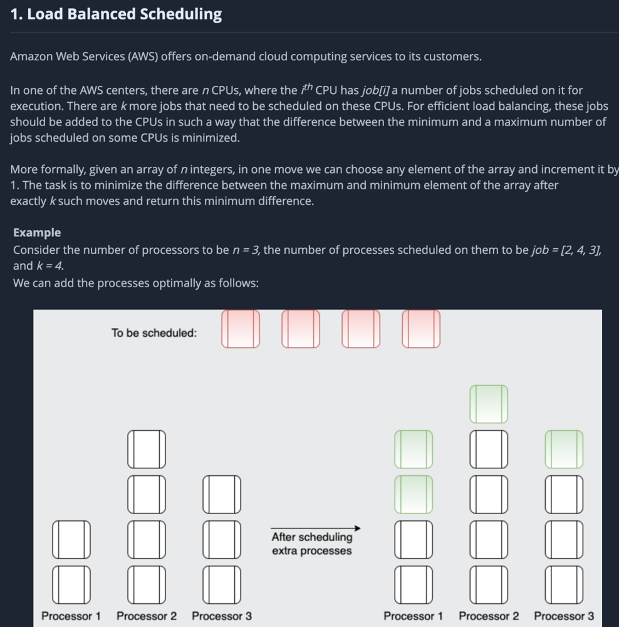

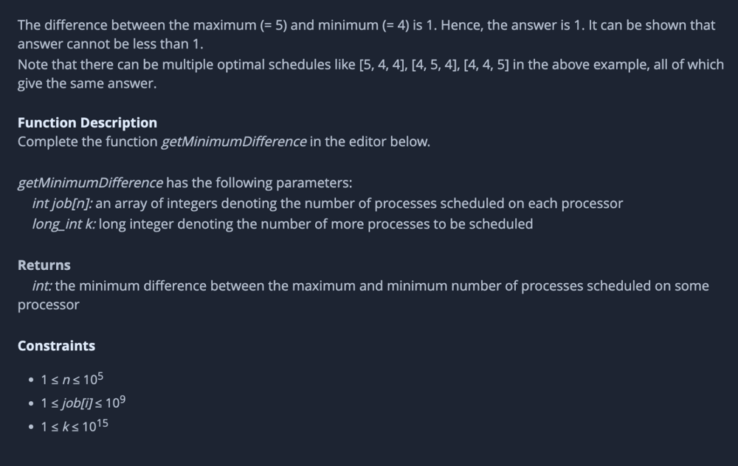

**Q) 17th March 2022**

**Given an array of integers -a- and a set of queries of the form [ l, r, x ], your task is to calculate the number of occurrences of the number x in the inclusive subarray a[l…r] (0-based), for each query, Return the sum of the answers for all queries as the result.**

**Example**

**for a=[1,2,1,3,1,2,1] and**

**arr = [ [1,3,3],**

**[0,4,1],**

**[2,5,2],**

**[5,6,1]**

**]**

**The output should be solution(queries) = 6.**

**-The answer to the first query is 1 : the number 3 appears 1 time in the subarray [2,1,3];**

**-The answer to the second query is 3: the number 1 appears 3 times in the subarray [1,2,1,3,1]:**

**-The answer to the third query is 1: the number 2 appears 1 time in the subarray [1,3,1,2];**

**-The answer to the fourth query is 1 : the number 1 appears 1 time in the subarray [2,1] .**

**-So the answer is 1 + 3 + 1 + 1 = 6.**

**Input/Output**

**[execution time limit] 3 seconds (java)**

**[input] array.integer a**

**An array of integers.**

**Guaranteed constraints**

**1 <= a.length <= 10^4**

**[input] array.array.integer queries**

**An array of queries, where queries [ i ] contains three numbers : l , r and x**

**Guaranteed constraints:**

**3<= queries.length <= 10^5**

**queries[ i ].length = 3,**

**0<= queries[ i ] [ 0 ] <= queries [ i ] [ 1] < a.length**

**1<= queries [ i ] [ 2 ] <= 100.**

**[output] integer**

**The sum of the answers to all queries**

**Int solution (int[] a , int [] [] queries ){**

**// solution here**

**}**

**Q) 5th March 2022**

[**https://leetcode.com/problems/trim-a-binary-search-tree/**](https://leetcode.com/problems/trim-a-binary-search-tree/)

**Q) 5th March 2022**

[**https://leetcode.com/problems/minimum-height-trees/**](https://leetcode.com/problems/minimum-height-trees/)

**Q) 5th March 2022**

[**https://leetcode.com/problems/house-robber/**](https://leetcode.com/problems/house-robber/)